Feature Image: Own a Legend – Explore Pre-Owned Rolex Deals Today!

Title:Why Pre-Owned Rolex Watches for Sale Are in High Demand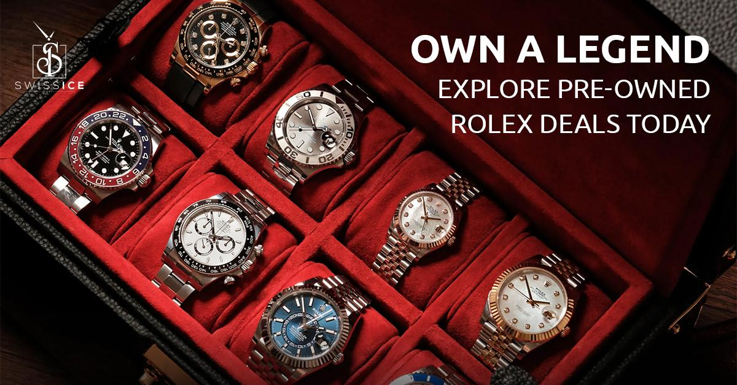
Focus Keyword: Pre-Owned Rolex Watches
Secondary Keyword:
rolex watch men
rolex watch women
Ladies Rolex watches
rolex watches for men
mens rolex watch

Internal Links:
rolex watch: https://swissiceco.com/collections/watches-rolex
best watch brands: https://swissiceco.com/

Why Pre-Owned Rolex Watches for Sale Are in High Demand H1
You see it everywhere. The unmistakable crown logo of Rolex. The smooth sweep of the seconds hand. The weight of quality on the wrist. Rolex isn't just a watch, it's a global symbol of achievement, precision, and timeless style.
But here at Swiss Ice Co, we know something crucial. You don't need a brand-new showroom purchase to own that prestige watch. The real savvy, the truly informed move, is exploring the world of pre-owned Rolex watches. And let us tell you, the demand for these exceptional timepieces has never been higher. We see it every single day in the conversations we have, the collections we curate, and the satisfied smiles when a client finds their perfect Rolex.
Let’s dive into why this market is booming and why it’s the absolute best way for you to enter the Rolex legacy.

The Compelling Value Proposition Behind Rolex Price Tag H2
Let’s address the elephant in the room first. Yes, choosing a pre-owned Rolex often means a significantly lower entry point compared to its brand-new counterpart. This is the most obvious driver of demand, but it’s far from the whole story. You can think Pre owned Rolex Watch Men and Women as a way to add incredible value immediately to your watch collection.
Here is why Pre owned Rolex watches justify their price tag:

Instant Depreciation Avoidance H2
A brand-new car loses value the moment you drive it off the lot. While Rolex watches hold their value remarkably well, they even experience a slight initial dip. By choosing pre-owned, you bypass that immediate depreciation. This way, you can project your investment in a better way. Moreover, if you like Rolex Submariner or GMT-Master II, and want to buy one. Don’t worry. You can buy them without breaking your bank. Rolex Submariner likely costs less today on the pre-owned market than it did brand new years ago, yet its intrinsic value and desirability remain incredibly strong.

Access to Higher Tiers H2
Maybe a brand-new, solid-gold Day-Date President is currently out of reach. The pre-owned market suddenly makes that iconic piece, a true symbol of success, attainable. We see clients regularly achieve their dream watch aspirations through our pre-owned Rolex watch women and men collection. This way, you can get any Rolex models that you thought were out of your range.

Better Option for Your Investment H2
Does your budget only stretch to a basic new Oyster Perpetual? In the pre-owned realm, it could open doors to a more complex model like a Datejust with a stunning fluted bezel and Jubilee bracelet, or perhaps even a professional model like an Explorer. You get significantly more horological substance and presence for your money.

Scarcity, Hype, and the Unobtainium Factor H2
When you walk into an authorized Rolex dealer today. What do you see? Beautiful displays, undoubtedly. But what you likely won’t see are the most sought-after professional models like the Daytona, the GMT-Master II "Pepsi" or "Batman," or even popular stainless steel Datejust 41 configurations.
Sometimes, waitlists stretch for years, sometimes indefinitely. But you don’t have to worry about anything when you shop your favorite men’s and ladies Rolex watches from Swiss Ice Co. Here is how Swiss Ice Co can help you obtain any model of your dream.

Bypassing the Waiting Game H2
Why wait years for a call that might never come? Swiss Ice Co offers immediate access to virtually any Rolex model you desire, from the sporty Submariner to the elegant ladies Rolex watches like the Datejust 31 in exquisite configurations. If you want a specific Rolex watch, especially one of the hyped "best watch brands" icons, pre-owned is the only practical route for you.

Get Discontinued Gems H3
Rolex's history is rich with discontinued models that have attained near-legendary status. You can think of any quirky yet beloved models like Rolex Men's Datejust with its green sapphire and lightning bolt seconds hand, or the distinct Datejust Turnograph, everything you will find in our collection. These pieces aren't just unavailable new, but they are also irreplaceable slices of horological history. The only place to find them? You guessed it right, the Swiss Ice Co. We carefully source these treasures, appreciating their unique stories.

Unique Designs & Built-to-Last Quality H3
Demand wouldn't stay high if the product weren't exceptional. Rolex’s enduring appeal rests on two rock-solid pillars that make it unique and special in the eyes of customers:

Iconic, Unchanging Design H3
A Rolex Datejust from the 1950s is instantly recognizable next to one made yesterday. The Oyster case and the Cyclops lens of Datejust are the design elements that are refined over decades, not discarded with fleeting trends. This consistency means a pre-owned Rolex never looks outdated. It looks classic. Whether it's a vintage mens Rolex watch or a contemporary Rolex watch women adore, the design language of each model speaks of enduring style.

Uncompromising Engineering & Materials H3
Rolex builds watches to last generations. Their use of 904L stainless steel (more corrosion-resistant than industry-standard 316L), their proprietary gold alloys like Everose, and their in-house manufactured movements rigorously tested to chronometer standards, this isn't marketing fluff. We see the evidence daily.
A well-maintained, 30-year-old Rolex movement often runs with accuracy that shames many new watches from other brands. This legendary durability is why pre-owned is a viable, smart option. When you are going to purchase Rolex watches for men or women, you aren't buying someone else's problem, but you're investing in proven, generational engineering.

A Sustainable & Ethical Choice for the Discerning Buyer H2
Today's luxury consumer is increasingly conscious. The pre-owned Rolex market aligns perfectly with this shift. Here is why Pre-Owned Rolex Watches are a better option for eco-conscious buyers:

Reduced Environmental Footprint H3
Manufacturing a new luxury watch requires significant resources such as mining metals, energy consumption, and transportation. Choosing pre-owned extends the life of an existing, meticulously crafted object. It’s the ultimate form of recycling, which gives a masterpiece a new chapter. You get the prestige and performance without the additional environmental burden of new production. It’s horological sustainability at its finest.

Countering Unethical Practices H3
At Swiss Ice Co, we source pre owned watches from reputable, transparent dealers and avoid all kinds of murky supply chains that can sometimes plague the mining of new materials for any luxury good. By focusing on existing watches, we sidestep those potential ethical pitfalls. Your conscience can rest as easily as your wrist.

Why Swiss Ice Co Should be Your Trusted Partner For Pre-Owned Rolex? H2
We aren't just another online listing. We are curators, authenticators, and passionate guardians of the Rolex legacy. We handle each watch with the respect these mechanical marvels deserve. Our collection reflects the incredible breadth of Rolex's history and appeal.
You'll find iconic Oyster Perpetual models in various sizes and vibrant dials, the commanding presence of the President Day-Date, the professional prowess of the GMT-Master II, the speed legend Daytona, and the sophisticated Sky-Dweller, among others. We meticulously source, authenticate, service, and present only the finest models.

Make Your Smart Move with Confidence H2
Choosing a pre-owned Rolex is a decision rooted in value, access, sustainability, and passion. But it must be done right. Here’s your action plan:

Define Your Desire H3
What model speaks to you? What size suits your wrist? Stainless steel, two-tone, or full gold? Sporty or elegant? Explore our collection to see the incredible range available now.

Prioritize Trust H3
Never compromise on the seller. Choose established, experienced experts with a proven track record of rigorous authentication and transparency. Ask about their process. Demand detailed photos and condition reports. Verify their physical presence and warranties. This is where Swiss Ice Co’s reputation is your bedrock.

Understand Condition & History H3
Scrutinize the provided information. Ask questions. A reputable dealer welcomes them. Understand the service history and what warranty backs the watch.

Enjoy the Journey H3
Finding your pre-owned Rolex should be exciting. Partner with Swiss Ice Co, which shares your passion and guides you with expertise.

Your Dream Pre Owned Rolex Awaits at Swiss Ice Co H2
The allure of Rolex is undeniable. The wisdom of choosing pre-owned is increasingly clear. It offers unparalleled value, immediate access to icons and history, a sustainable choice, and the thrill of finding a truly unique timepiece. Forget the waiting lists and the limitations of the new market. The world of pre-owned Rolex watches for sale is vibrant, diverse, and ready to welcome you.
At Swiss Ice Co, we’ve dedicated ourselves to being the most knowledgeable, trustworthy source for your pre-owned Rolex journey. We don’t just sell watches, we help you acquire a piece of horological legend, a testament to enduring quality and style, at a point of exceptional value. Your perfect Rolex, rich with history and ready for your story, is waiting. Let us help you discover it. Explore our curated collection today and experience the Swiss Ice Co difference. Your legacy timepiece is closer than you think.

GMB
Find out why savvy watch lovers globally are choosing pre-owned Rolex watches. At Swiss Ice Co, we specialize in authentic, certified pre-owned Rolex timepieces, offering exceptional value and immediate access to iconic models often unavailable new. Skip years-long waitlists at Swiss Ice Co. Find your dream Rolex Submariner, Daytona, GMT Master II, Datejust, or Day Date President today. We meticulously source, authenticate, and service every watch in our diverse collection. Experience the Rolex legacy without the new price tag. Our experts provide unparalleled insight into timeless designs like the Oyster Perpetual, robust engineering built to last generations, and the sustainable advantage of pre owned luxury. Avoid depreciation and access higher-tier models like solid gold pieces sooner. We understand the market’s challenges, including counterfeits. That’s why our master watchmakers perform exhaustive multi-point authentication and full servicing, ensuring accuracy, water resistance, and transparency on condition. Want to own your icon now? Visit Swiss Ice Co today for authentic pre-owned Rolex watches for sale.

